Seller Onboarding Email

Instructions
 Create a new email
 Copy and paste the text below into your email
 (Optional) Edit the text to match your brand’s in-house style
 Open Seller Disclosure Statement (Form 2) Info Flyer (Digital) and add your logo
 Save it and attach to the email
 Add your recipient and hit send

SUBJECT LINE OF EMAIL
Important Next Step: Complete your Form 2 Disclosure

BODY
Hi [Seller Name]

We're excited to get your property on the market. Before we do, there's a crucial compliance step to tick off: the Seller Disclosure Statement (Form 2).

Under Queensland’s updated Property Law Act, we must provide this Statement to Buyers before the Contract of Sale is signed. Don't stress—we've partnered with Griffiths Parry Lawyers to keep this simple for you.

Here's what you need to do
Griffiths Parry Lawyers have made it super easy for you. All you need to do is:

- Click this link or scan the QR code below if you wish to complete this via mobile:
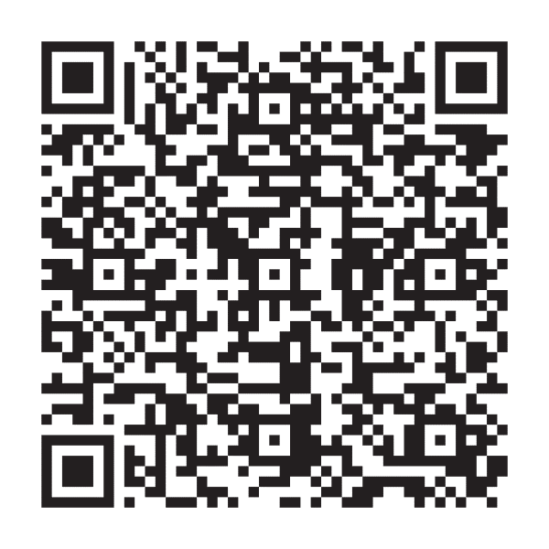
- Answer a few questions online (it takes just a few minutes).
- Griffiths Parry Lawyers will handle the rest—conducting the necessary searches, preparing your Disclosure Statement, and sending it back to us ready for signing.

Estimate of legal fees & costs for Seller Disclosure Statement
Griffiths Parry Lawyers have fixed their legal fee for this stage at $550.00.

Combined with the necessary council searches and other outlays, the estimated total cost Click here to select estimated cost based on property value.

Final pricing varies by what searches are required, what documents you may already have and the council that has jurisdiction over the property.

All pricing listed is inclusive of GST.

It’s quick, easy, and ensures your sale process runs smoothly from start to finish. If you have questions, just give me a shout—otherwise, let's get your sale moving!

[insert email signature]

